Kubernetes Pods

When you created a Deployment in Module [2](https://kubernetes.io/docs/tutorials/kubernetes-basics/deploy-app/deploy-intro/), Kubernetes created a **Pod** to host your application instance. A Pod is a Kubernetes abstraction that represents a group of one or more application containers (such as Docker), and some shared resources for those containers. Those resources include:

* Shared storage, as Volumes
* Networking, as a unique cluster IP address
* Information about how to run each container, such as the container image version or specific ports to use

Pod deployment

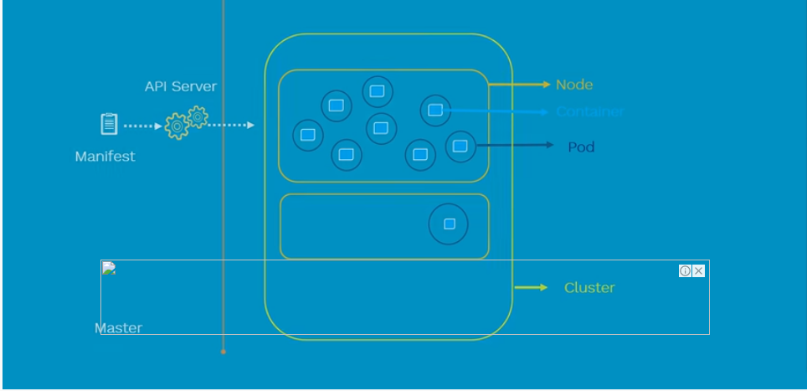

Multi deployment

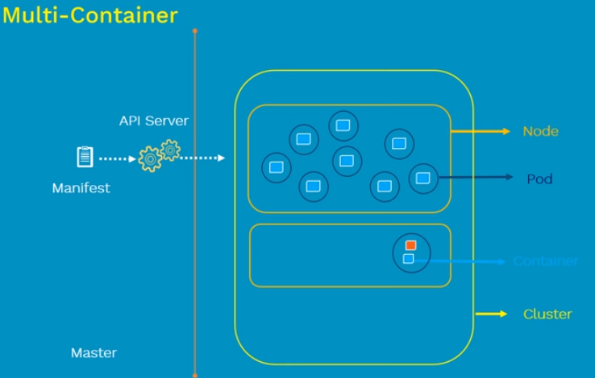

Pod Networking #network with in the pods

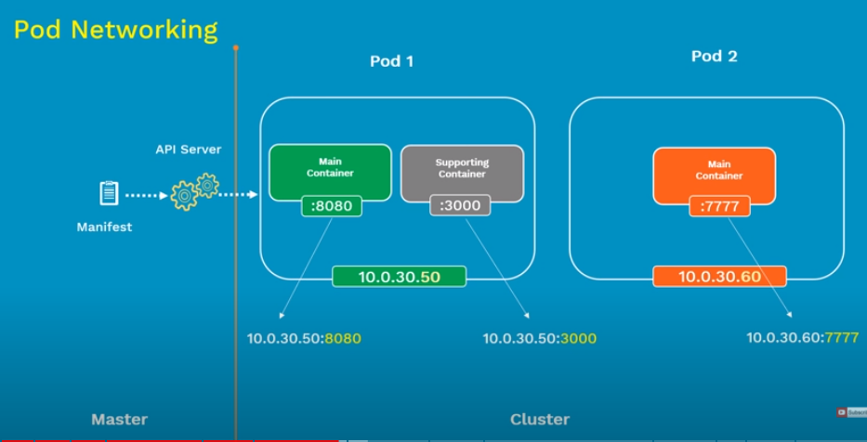

Inter pod network # network to connect one to another

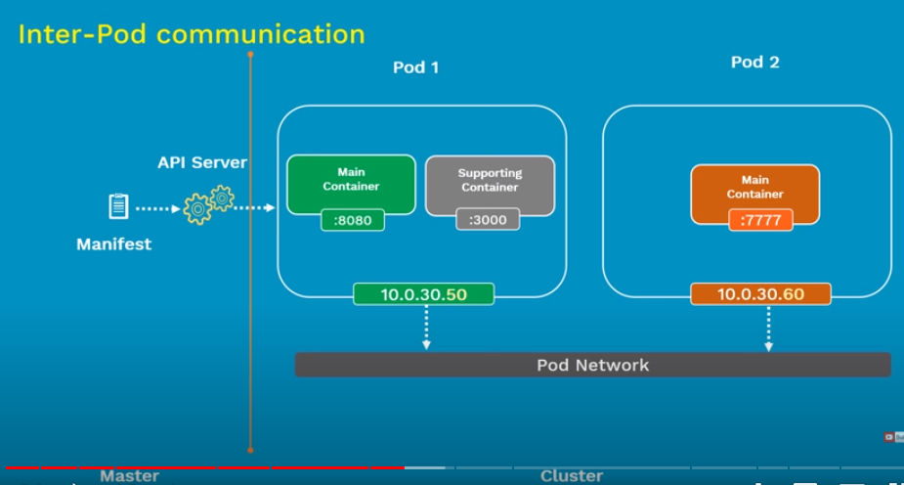

Intra-pod-network # network connection with in the pod

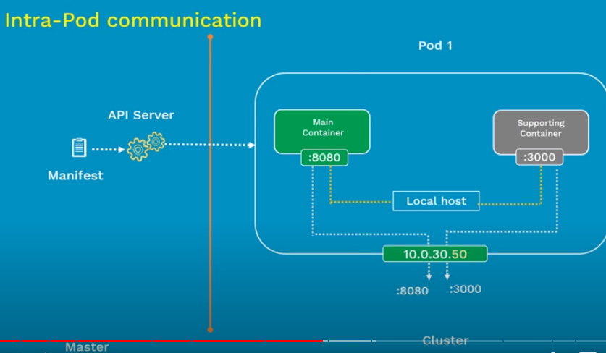

Pod –lifecycle

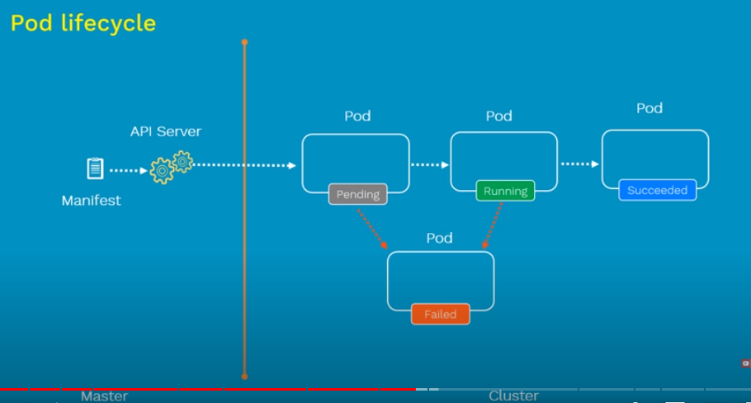

Pod –config # pod yamal

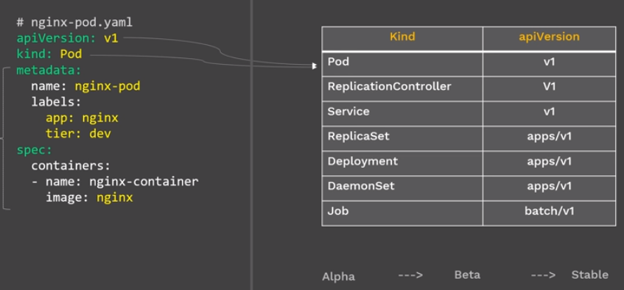

Commands:

Kubectl create –f pod-name.yml

Kubectl get pod

Kubectl get pod - o wide

Kubectl get pod pod-name– o yaml

Kubectl describe pod pod-name

Testing # ping ip-adress

Kubectl exce –it pod-name -- /bin/sh

Kubectl delete pod pod-name